- Prompted: This is my code for my player I want the player to move using W,A,S,D and jump using space
It works! I need to fix the jumping onto the platforms since it is a bit glitchy
The player is still flying so I will also try to remove that soon

- Prompted: This is my player and platform code, I want them to work together better so the player can jump onto the platform and jump through the platform and stay on top of it

- Prompted: Whats wrong with the jack_update and jack_bottom, it showed me what was wrong and I fixed it. The code and didn’t specify what was wrong with the update and bottom so I had to prompt help me fix Jack_Update and then it actually helped

- Promped: help me make a main menu like the image there
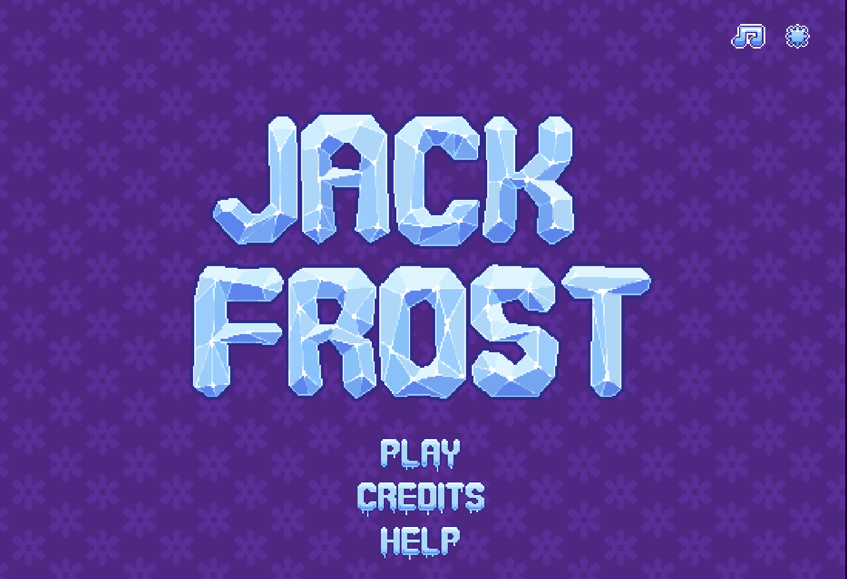
Which didn’t work so that is what I’m going to work on in the next session

